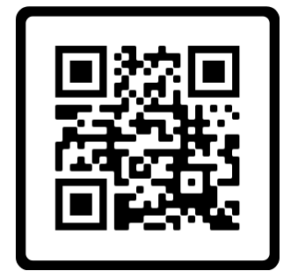 Patrick R. Porter

2218 Trellis Ridge Lane ∙ De Pere, WI 54115 ∙ Cell (920) 241-2515

Email: patrick@ironsinthefire.dev

Web: www.ironsinthefiire.dev



**SUMMARY:** A highly dedicated worker with effective communication, leadership and interpersonal skills. Strong technical aptitude and people skills.

**RELATED EXPERIENCE:**

**Senior Systems Analyst** American Foods Group(2016-present)

* Planned, designed, developed, and deployed new applications, and enhancements to existing applications.
* Wrote Enterprise Harvest System
* Maintained proprietary software systems
* Mentored Junior employees
* Helped Develop and maintain internal website using .Net and MVC

**Business Systems Analyst/Developer** Pioneer Metal Finishing (2014-2016)

* Gather requirements for software projects
* Work with SQL to develop SSRS reports
* Investigate and help implement new ERP
* Develop and maintain internal department website using outside API’s
* Provide analysis and development for custom C# Applications

**Applications Engineer** Humana, De Pere, Wisconsin (2009-2013)

* Automate Humana systems using the Winbatch and C# languages
* Writing XML Generated reports using SQL and C#
  + Wrote SSIS packages to flow data to clients
  + Wrote web services using C# and ASP.Net
  + Wrote several work-related tools in C# during off-hours
  + Providing training in C# to department as ‘Lunch and Learns’
  + SSRS Reporting

**VDP Format Programmer** R.R. DONNELLEY, De Pere, Wisconsin (2006-2009)

* Created custom programs to process client data for use in Variable Data Printing
* Developed tools used by production programmers to automatically build and change XML schemas, interface with the mainframe, and convert files into hexadecimal form, Application used the company's Informix database. VB.NET, Informix, XML, COM, Mainframe
* Developed a notification system to provide a means for managers to schedule automatic status updates about order due dates.
* Created and maintained new SharePoint site for production programmers.
* Developed and instituted coding and program creation standards for production programming.

**EDUCATION:**

NORTHEAST WISCONSIN TECHNICAL COLLEGE, Green Bay, Wisconsin

* Associate Degree, Microcomputer Specialist, May 2006

**MILITARY SERVICE:**

US Navy (1988-1994)

Boiler Technician 3rd Class Petty Officer.